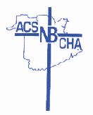
REGISTRATION FORM

Catholic Health Association of New-Brunswick
2018
You can complete this form online, click on the email icon at the top of your screen and sent to: ebowes@chpchi.com, or you can fax to 506-778-5303.
Name:

Position:

Facility:

Mailing Address:

City & Postal Code:

Telephone: Work ( ) Cell: ( )

Fax: ( ) email:

Will you be attending the banquet?:
Will you be bringing a guest? (additional $20):

Reply to:

Ms. Eileen Bowes

Catholic Health International 1773 rue Water Street Miramichi, NB
E1N 1B2

Tel: 506-778-5302 Fax: 506-778-5303

